***Assignment Name****:* ***Lab4:******(Selection: if statement, if else statement)***

***Due date:******10/5/2022, by 11:00 am.***

***Grade for assignment: 30*** *points*

***Purpose:*** *Obtain experience in using operators and selection statements when writing programs. Assignment accomplishes course learning objective “using basic control structures”. Assignment also provides preparation for COSC236 course, and enhances skills needed in Information Technology (IT) and Computer Science industries.*

***Skills:*** *Purpose of assignment is to help you practice the following skills.*

*-Recognize when to use selection statements.*

*-Ability to effectively use operators.*

***Knowledge:*** *Become familiar with decision control structures when writing computer programs.*

***\*\*\*\*\*\*\*\*\*\*\*\*\*\*\*\*\*\*\*\*\*\*\*\*\*\*\*\*\*\*\*\*\*\*\*\*\*\*\*\*\*\*\*\*\*\*\*\*\*\*\*\*\*\*\*\*\*\*\*\*\*\*\*\*\*\*\*\*\*\*\*\*\*\*\*\****

***Place your Name(s) below:***

***Pairs work:*** *Please work in pairs.* ***One student in team should submit work****. Put* ***your first and last name on the assignment*** *and* ***your partner’s first and last name on the*** *assignment*

***Note(s):***

1. *All programs should be completed within the Visual Studio Code environment. There are guides in blackboard to start you off with Visual Studio Code.*

***Partner 1: Name* Blessing Abumere**

***role (did the typing or read and review) _____________________________***

***Partner 2: Name ______________________________________________***

***role (did the typing or read and review)______________________________***

***Please note if one partner did not work on all problems.***

***Submission instructions:*** *All submissions will be done using blackboard.* ***Answers are to be submitted in a Microsoft word document.***

***Task****:*

***Examples:*** *Refer to your notes from class, the Operators PowerPoint and the Selection PowerPoint and any available videos (all located in Blackboard).*

***Part1 (15 Points):***

1. *Type in the following program. Add a comment at the top to include your name(s) and the date.*

#include <iostream>

using namespace std;

int main()

{

      float applePrice;

float orangePrice;

      cout << "Please enter apple price" << endl;

      cin >> applePrice;

      cout << "Please enter orange price" << endl;

      cin >> orangePrice;

      if (applePrice >= orangePrice)

      {

            cout <<"Apples Cost More" << endl;

      }

      else if (orangePrice >= applePrice)

      {

            cout <<"Oranges Cost More" << endl;

      }

      else

      {

            cout <<"Apples and Oranges Cost the Same" << endl;

      }

      return 0;

}

*a) Compile and Run with different values.*

1. *Find the logic error. Correct it and submit the final program with* ***3 sample outputs demonstrating*** *all three clauses.*
2. ***SUBMIT your corrected code, and sample of output (Below):***

/*

    Blessing Abumere

    9/28/2022

    GEN COMPUTER SCI (COSC175006)-1224

*/

#include <iostream>

using namespace std;

int main(){

    float applePrice;

    float orangePrice;

    cout << "Please enter apple price" << endl;

        cin >> applePrice;

    cout << "Please enter orange price" << endl;

        cin >> orangePrice;

    if (applePrice > orangePrice)

    {

        cout <<"Apples Cost More" << endl;

    }

    else if (orangePrice > applePrice)

    {

        cout <<"Oranges Cost More" << endl;

    }

    else

    {

        cout <<"Apples and Oranges Cost the Same" << endl;

    }

    return 0;

}

***Part2 (15 points):***

1. *Type in the following program. Add a comment at the top to include your name(s) and the date.*

*#include <iostream>*

*using namespace std;*

*int main()*

*{*

*int testScore;*

*cout << "Enter test score" << endl;*

*cin >> testScore;*

*if (testScore >= 90)*

*cout << "Your grade is A" << endl;*

*else if (testScore >= 80)*

*cout << "Your grade is B" << endl;*

*else if (testScore >= 70)*

*cout << "Your grade is C" << endl;*

*else if (testScore >= 60)*

*cout << "Your grade is D" << endl;*

*else*

*cout << "Your grade is F" << endl;*

*return 0;*

*}*

*a) Compile and Run with different values.*

*b) What happens if you enter 110? -5? What should happen?*

* When Inputting 110 the program says “Your grade is A”
* When inputting -5 the program says “Your grade is F”
* The program should make the user know that those inputs are not possible grade percentages .

1. *Add code to print "Invalid" if values above 100 or below 0 are entered.*

*d)* ***SUBMIT your corrected code, and sample of output (Below):***

/*

    Blessing Abumere

    9/28/2022

    GEN COMPUTER SCI (COSC175006)-1224

*/

#include <iostream>

using namespace std;

int main(){

    int testScore;

    cout << "Enter test score" << endl;

        cin >> testScore;

            if (testScore > 100 || testScore < 0){

                cout << "Invalid Test Score";

                return 0;

            }

    if (testScore >= 90)

        cout << "Your grade is A" << endl;

    else if (testScore >= 80)

        cout << "Your grade is B" << endl;

    else if (testScore >= 70)

        cout << "Your grade is C" << endl;

    else if (testScore >= 60)

        cout << "Your grade is D" << endl;

    else

        cout << "Your grade is F" << endl;

    return 0;

}

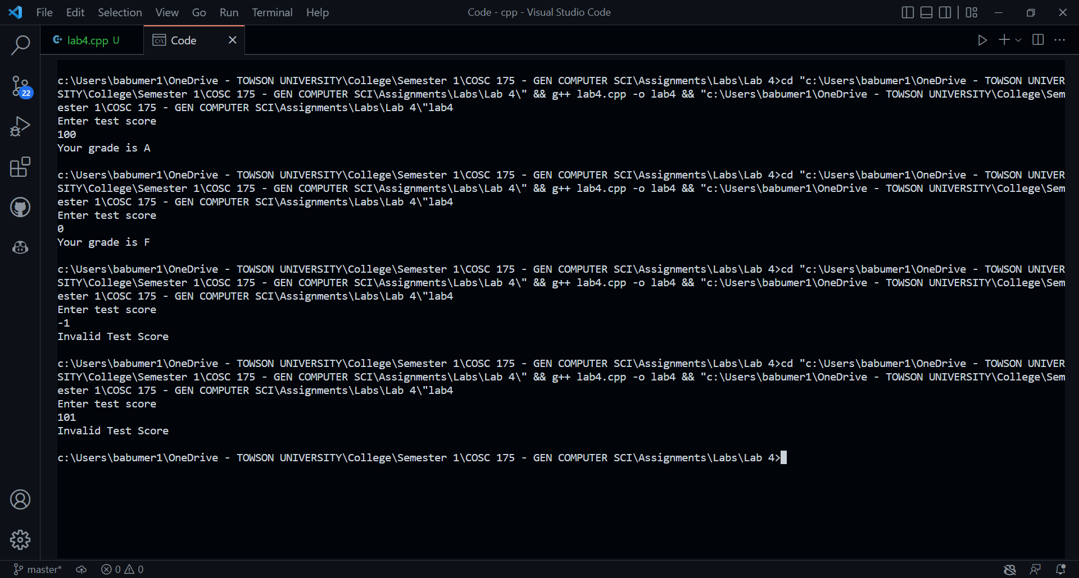

***\*\*\*\*\*\*\*\*\*\*\*\*\*\*\*\*\*\*\*\*\*\*\*\*\*\*\*\*\*\*\*\*\*\*\*\*\*\*\*\*\*\*\*\*\*\*\*\*\*\*\*\*\*\*\*\*\*\*\*\*\*\*\*\*\*\*\*\*\*\*\*\*\*\*\*\*\****

***Criteria for Success****:*

***a****) Be sure to submit your code and output above for each question;* ***Submission of Code and output is required****. (Note: use screen shots or copy and paste).*

*For example if the assignment was to write a program that displays “Hello World”*

*Your* ***code*** *would be as follows:*

*//Lab1 answer COSC175002*

*#include <iostream>*

*using namespace std;*

*int main()*

*{*

*cout << "Hello, world" << endl;*

*system("pause");*

*} // end of main*

*Your* ***output*** *would be as follows:*

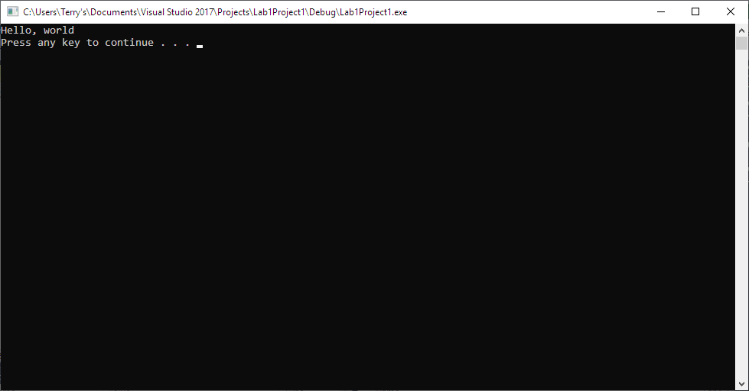

*Note: To avoid additional point deductions; remember to submit both code and output.*

***b) Late policy:*** *Late submissions will receive a zero grade. Get help during the week so that you can submit on time.*